The Alaska Community Foundation (ACF) and Your organization name are working together to share resources and support the causes in Alaska that you care about.

By providing Alaskans with a variety of giving options, ACF connects people who care with causes that matter. Guided by a statewide Board of Directors, ACF awards grants to charitable organizations, provides scholarships and manages nonprofit agency funds. We convene leaders and organizations across Alaska to address emerging and long-term community needs.
ACF’s primary focus is to help Alaskans give to long-term funds including endowments, which are permanent pooled assets that generate income. These funds support the causes our communities care about and allow nonprofits to address current and future needs.
Today, the Alaska Community Foundation manages more than $78 million in assets. Many Alaskans have committed to future gifts through their wills and retirement accounts, leaving a legacy that will support the causes they care about forever.

How Does An Endowment Work?
An endowment is a “savings account” that grows through financial contributions from donors and strategic investing. The Alaska Community Foundation offers a well-balanced, diversified portfolio that focuses on long-term growth. The proceeds earned are used to support nonprofits or projects fulfilling important community needs.
Donors to endowments want to ensure the future prosperity of their community and the organizations they care about. Gifts to endowments don’t have to be large to make a significant impact.
Whatever the size of the gift, donors make it with the intention of having it prudently invested and protected for the future. When ACF accepts an endowment gift, the foundation ensures your wishes and intent will be observed.

Your Organization Name Here
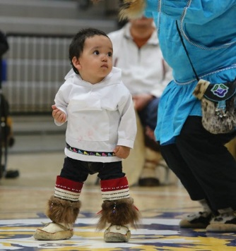
Interested in learning more? Contact us!
The Alaska Community Foundation info@alaskacf.org (907) 334 - 6700

Agency Funds Endowment Overview

Your organization name established a fund at The Alaska Community Foundation (ACF) to ensure a stable and sustainable future.

Your organization name is working with ACF to grow this fund and ensure that donors’ gifts continue to make a difference in our community.

Whys give to our fund at The Alaska Community Foundation?
- ACF is a 100% local organization with deep roots in the community.
- ACF has broad expertise regarding community issues and needs.
- Your gift today will be invested by ACF and will earn returns every year from the moment you make it.
- ACF provides professional investment expertise, manages our endowment, files the tax returns, and distributes the income from our endowment to our organization.
- ACF manages many complex assets, and can facilitate even the most complex forms of giving.
- ACF partners with professional advisors to create highly effective approaches to charitble giving and can offer maximum tax advantages for most gifts.
- ACF can multiply the impact of your gifts by pooling it with other donations.

