Press and Public Relations
Media coverage can raise awareness and help you to achieve your goals.
Here is a sample press release. Please feel free to use this template for your own press releases. If you decide to draft your own press releases, please send them to the ACF Communications Specialist for review, as well as distribution, if you need or desire assistance in distribution of the press release to media outlets.
Always include this stock information in your press release. Please always include a contact at ACF as well as someone with your Affiliate.
FOR IMMEDIATE RELEASE
Date

MEDIA CONTACT:
Name
Email
Phone

Foundation to host seminar on fundraising 101

The Jessica Stevens Community Foundation, an Affiliate of The Alaska Community Foundation (ACF), is offering a free seminar on grant-writing and successful fundraising for Northern Susitna-region nonprofit organizations on Wednesday, September 19, 2012 from 10:00 a.m. to 2:00 p.m., at the Northern Susitna Institute. Regional funders will discuss what makes a project attractive to their organizations and will attempt to ease some of the discomfort associated with requesting funding.

The seminar will begin with a review of grant writing essentials with Anne Remick, program officer for The Alaska Community Foundation, and a lunch roundtable discussion on “Strategies for Success” with Sondra Porter, president of the Talkeetna-based Jessica Stevens Community Foundation advisory board. Aleesha Towns-Bain, senior program associate at the Rasmuson Foundation, and Sharon Scott, program officer of Mat-Su Health Foundation, will provide an overview of grant opportunities through their respective foundations. Nonprofit board, staff and volunteer leadership are welcome to attend this free seminar. Leaders should be prepared to discuss their organization’s overall mission and current activities. Lunch will be provided.

For more information and to register for the seminar, contact [Name] at
(907) 733-2388 or name@alaskacf.org.

###

About the Jessica Stevens Community Foundation
The Jessica Stevens Community Foundation, an Affiliate of The Alaska Community Foundation, is a permanent fund dedicated to building healthy communities in the Northern Susitna Valley by raising a perpetual endowment to address community needs now and into the future. Over 120 families, business, individuals and foundations have contributed to create the permanent endowment at JSCF. Earnings from the fund are distributed annually through grants to local nonprofits. More information is available at www.jessicastevenscf.org.

About The Alaska Community Foundation
Established in 1995, The Alaska Community Foundation is a statewide platform for philanthropy that connects people who care with causes that matter. Holding approximately $79 million in more than 400 funds for the benefit of Alaskans, ACF grants $3-4 million each year to charitable projects and nonprofit organizations across the state. Our mission is to inspire the spirit of giving and connect people, organizations and causes to strengthen Alaska’s communities now and forever.. For more information, visit www.alaskacf.org or call (907) 334-6700.

Your press release title should be short, simple and explain exactly what the release is about. You may include a subtitle also.

Engage your reader in the first paragraph. Include the pertinent details, including time and place of an event or deadlines for a grant or scholarship application. Typically, you want to also include some engagement in the first paragraph, e.g. explain why this is newsworthy.

If you are hosting an event, offering a grant application, or otherwise calling your reader to do something, make sure you include a contact where readers can get more information, typically a phone number, email address and your website.

The ### indicates the end of your press release.

Develop boilerplate paragraph about your Affiliate community foundation to include in all press releases.

Please use this boilerplate for The Alaska Community Foundation following boilerplate about your Affiliate community foundation.

Do not use “I” or “we.” Refer to yourself from a journalist’s perspective.
Shorter is better. If you can say it in one page, do so. Do not go over two pages.
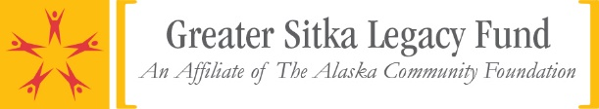
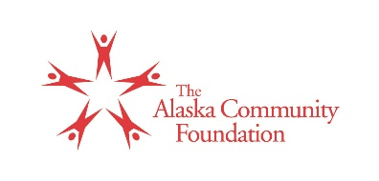
Media Contact:
Name
Email
Phone

Shawn Rivera
Affiliate Program Officer
srivera@alaskacf.org
907-274-6708

TITLE
Subtitle

(City, ALASKA) –

###

[Your boilerplate content here]

Established in 1995, The Alaska Community Foundation is a statewide platform for philanthropy that connects people who care with causes that matter. Holding approximately $79 million in more than 400 funds for the benefit of Alaskans, ACF grants $3-4 million each year to charitable projects and nonprofit organizations across the state. Our mission is to inspire the spirit of giving and connect people, organizations and causes to strengthen Alaska’s communities now and forever.. For more information, visit www.alaskacf.org or call (907) 334-6700.

